9/30/2016

V-Menu Restaurant Management System

Building the Restaurant of Tomorrow Today

**School:** University of North Florida

**Course:** Software Engineering (CEN 4010)

**Instructor:** Dr. Douglas Leas

**Leader Developer:** Matthew Boyette

**Lead Designer:** David Hughes

**Developer:** William Mejia

**Developer:** Demetrius Myers

**Developer:** Slaven Popadic

Table of Contents

Overview 2

Project Team 2

High-Level Use Case Diagram 3

Use Case Summary 4

# Overview

V-Menu is a system designed to turn the day-to-day logistics of managing a restaurant into a problem solvable using distributed computing. By turning the individual human elements of the restaurant into computable problems, we hope to push the boundaries and take the next step toward a completely automated restaurant. Although a fully automated restaurant is still relatively infeasible with today’s level of off-the-shelf consumer technology, it won’t be long before advances in robotics make such an occurrence not only practical, but also commonplace. There are three primary factors of functionality that must be addressed before robotic employees become ready for mainstream adoption.

* Precision of movement. Tasks like cooking and waiting tables require precise movements, and the objects being moved are designed to be manipulated by a human hand.
* Collision avoidance. A restaurant is usually a bustling place with a great deal of movement (not only by employees, but also customers). Being able to avoid colliding with obstacles is critical.
* Communication interface. Computerized speech recognition still has some ways to go before a randomly chosen customer can reliably communicate their orders verbally to a robotic employee.

Many restaurants currently have similar systems in place already, but the feature-set and overall design is inconsistent. Further, many of these systems focus solely on patrons who want food delivered to an exterior location, or patrons who wish to pick up their food at the restaurant and then take it with them to dine elsewhere (usually a home or office).

Our goal is two-fold: to serve the needs of those dining inside the restaurant, and to merge the functionality of existing systems for a consistent design and interface which can be easily customized or extended to suit each individual client.

# Project Team

* Matthew is the team leader and lead developer. The parts of this deliverable that he contributed are the title page, table of contents, and the overview (this page). He also participated in the presentation of our requirements to the class.
* David is the lead designer. The parts of this deliverable that he contributed are the individual use-case diagrams. He also participated in the presentation of our requirements to the class.
* William is a developer. The parts of this deliverable that he contributed are filling in use case details.
* Demetrius is a developer. The parts of this deliverable that he contributed are filling in use case details.
* Slaven is a developer. The parts of this deliverable that he contributed are filling in use case details. He also contributed significantly to the slides used in our presentation.

Additionally, every member of the team participated in constructing the high-level use case diagram during our team meetings.

# High-Level Use Case Diagram

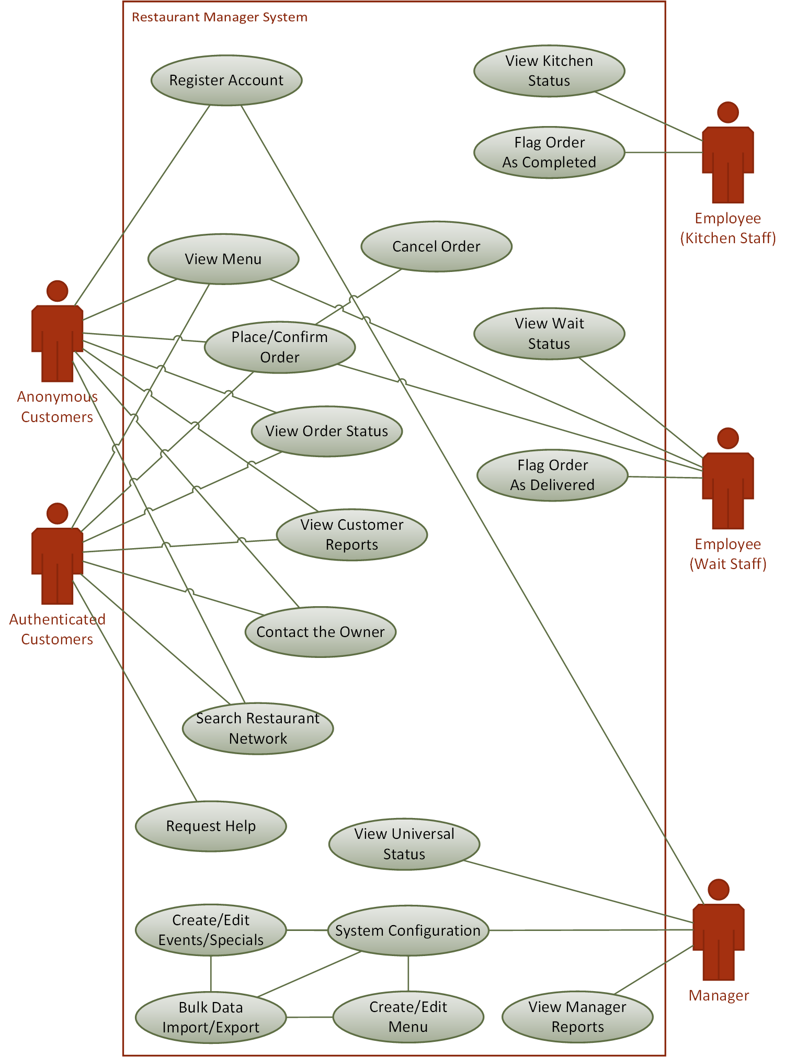

# Use Case Summary